**ABSTRACT**: Employee attrition is a critical challenge for organizations, impacting productivity, morale, and operational costs. Understanding the factors contributing to employee turnover is essential for developing strategies to retain talent. This research aims to predict employee attrition using a machine learning-based prediction model, underpinned by comprehensive data analysis.

The study begins with data collection from organizational records, including variables such as demographic information, job role, salary, years at the company, performance ratings, and work-life balance indicators. The dataset is carefully cleaned and preprocessed, handling missing values, outliers, and transforming categorical variables into numerical formats using techniques such as one-hot encoding and label encoding.

Exploratory Data Analysis (EDA) is conducted to understand the distribution of the data and uncover key trends and patterns. Statistical insights from the EDA reveal significant factors associated with attrition, such as low job satisfaction, limited career advancement opportunities, and work-life balance issues. Visualizations such as histograms, box plots, and correlation heatmaps provide a deeper understanding of the relationships between variables and attrition outcomes.

Following data analysis, multiple machine learning algorithms are applied to build a predictive model for employee attrition. Algorithms such as Logistic Regression, Random Forest, Decision Trees, and Gradient Boosting are tested, and their performance is compared based on metrics such as accuracy, precision, recall, and F1 score. Hyperparameter tuning is performed to optimize the models for better prediction. The final model is selected based on its ability to generalize well on unseen data, with a focus on minimizing false positives and false negatives in attrition prediction.

The findings from the predictive model reveal that factors like job satisfaction, performance ratings, and years spent at the company are among the most influential in predicting whether an employee is likely to leave the organization. The model's predictions can help HR teams proactively identify at-risk employees and intervene with personalized retention strategies.

This research demonstrates the potential of machine learning in predicting employee attrition and underscores the importance of data-driven decision-making in talent management. By leveraging predictive analytics, organizations can reduce turnover rates, enhance employee retention, and foster a more stable workforce.

This abstract summarizes your research involving machine learning and data analysis for developing an employee attrition prediction system.

**1.INTRODUCTION**

**1.1 Background**

In today’s competitive business landscape, employee attrition has become a significant concern for organizations across various industries. High turnover rates not only disrupt business operations but also lead to increased costs related to recruitment, onboarding, and training of new employees. Retaining key talent is, therefore, essential for maintaining productivity and a healthy workplace culture. However, understanding the reasons behind employee attrition and predicting which employees are at risk of leaving poses a complex challenge due to the multitude of factors involved.

This research project focuses on the development of an employee attrition prediction system using machine learning techniques, aiming to provide organizations with insights into employee behaviour and attrition trends. The system is designed to predict which employees are likely to leave based on historical employee data, thus enabling companies to take proactive measures to retain valuable talent.

The project begins with extensive data analysis of employee records, encompassing a variety of factors such as job satisfaction, performance ratings, salary, job role, work-life balance, and tenure at the company. This analysis serves as the foundation for building a predictive model. By identifying key drivers of attrition, the model aims to forecast employee turnover with high accuracy, providing HR teams with actionable insights.

Through the application of machine learning algorithms, including Logistic Regression, Decision Trees, Random Forests, and Gradient Boosting, the system is capable of learning patterns and relationships between employee characteristics and attrition. The use of advanced data preprocessing and feature selection ensures that the predictive model is both robust and interpretable.

This project leverages the power of data-driven decision-making, helping organizations mitigate the risks associated with high employee turnover. By predicting potential attrition early, businesses can implement targeted retention strategies, improve employee satisfaction, and ultimately reduce the costs associated with high attrition rates.

In summary, the employee attrition prediction system integrates data analytics and machine learning to provide a comprehensive solution for predicting turnover, contributing to more efficient talent management and a more stable workforce.

**1.2 Objectives**

The primary objective of this project is to develop an employee attrition prediction system using machine learning techniques that can accurately forecast which employees are at risk of leaving the organization. This predictive system aims to enable organizations to proactively identify and address the factors contributing to attrition, ultimately reducing turnover and enhancing employee retention strategies.

The specific objectives of the project are as follows:

1. Data Collection and Preprocessing:

- Collect relevant employee data such as demographic information, job role, performance ratings, tenure, and work-life balance indicators.

- Clean and preprocess the data, handling missing values, outliers, and transforming categorical data into suitable formats for analysis.

2. Exploratory Data Analysis (EDA):

- Conduct exploratory data analysis to identify key patterns, trends, and relationships between different variables and employee attrition.

- Visualize the data using charts, histograms, and correlation heatmaps to gain insights into the factors most associated with turnover.

3. Feature Selection and Engineering:

- Identify and select the most significant features that contribute to employee attrition.

- Perform feature engineering to improve the predictive power of the machine learning models.

4. Model Development:

- Develop multiple machine learning models, including Logistic Regression, Decision Trees, Random Forest, and Gradient Boosting, to predict employee attrition.

- Compare the performance of these models using key evaluation metrics such as accuracy, precision, recall, and F1 score.

5. Model Optimization:

- Fine-tune the models through hyperparameter optimization to improve their accuracy and generalization capabilities.

- Select the best-performing model based on cross-validation results and test it on unseen data.

6. Implementation and Integration:

- Implement the final predictive model and integrate it into a user-friendly system that can be utilized by HR professionals for real-time attrition predictions.

- Provide actionable insights and recommendations for organizations to implement retention strategies based on model outputs.

7. Evaluate and Validate the System:

- Evaluate the system’s performance by analyzing its prediction accuracy on test datasets.

- Validate the system’s utility by assessing its effectiveness in helping HR teams identify at-risk employees and reduce turnover rates.

The successful completion of these objectives will result in a robust and practical tool for organizations to better understand and mitigate the risk of employee attrition.

**1.3 Purpose, Scope, and Applicability**

**1.3.1 Purpose**

The purpose of this project is to develop a machine learning-based employee attrition prediction system that helps organizations identify employees who are at risk of leaving. By providing HR teams with predictive insights, the system aims to support proactive retention strategies and reduce turnover rates. The project seeks to explore how various factors such as job satisfaction, salary, performance, and work-life balance contribute to attrition, and leverage these factors to build an accurate predictive model. Ultimately, the purpose is to enhance talent management by allowing organizations to address the underlying causes of attrition and implement targeted interventions to retain valuable employees.

**1.3.2 Scope**

The scope of the project includes the entire process of building a predictive system for employee attrition, from data collection to model deployment. This includes:

1. Data Collection: Gathering data from employee records, including demographics, job performance, role, and work-related attributes.

2. Data Preprocessing and Analysis: Cleaning, transforming, and analyzing the data to identify key factors influencing attrition.

3. Model Development: Developing and testing various machine learning models such as Logistic Regression, Decision Trees, Random Forest, and Gradient Boosting to predict employee attrition.

4. Model Evaluation: Evaluating the models using performance metrics like accuracy, precision, recall, and F1 score to determine the most effective one.

5. System Implementation: Creating a practical system that allows HR professionals to input employee data and receive predictions on potential attrition risks.

6. Recommendations and Insights: Providing insights based on model predictions to assist in the creation of retention strategies.

7. Future Enhancements: Suggestions for system scalability and integration with other HR tools, as well as potential improvements to the prediction models.

The scope does not include live implementation with a specific organization or real-time updates of employee data, but it does account for a scalable system that can be adapted for use by businesses in various industries.

**1.3.3 Applicability**

The system is applicable to organizations of all sizes across various industries that are experiencing challenges with employee turnover. It can be applied by HR teams, managers, and decision-makers to:

1. Proactively Identify At-Risk Employees: By predicting which employees are likely to leave, organizations can target retention efforts more effectively, reducing the need for reactive measures.

2. Optimize Retention Strategies: Insights provided by the system can help HR professionals develop strategies tailored to the needs and concerns of employees, enhancing job satisfaction and work-life balance.

3. Improve Workforce Planning: By understanding attrition trends, organizations can better plan for recruitment, succession, and resource allocation.

4. Enhance Employee Engagement: Early identification of dissatisfaction factors allows for targeted interventions to improve engagement and morale, creating a more positive work environment.

This system is particularly beneficial to industries with high turnover rates, such as retail, hospitality, customer service, and tech sectors, but is flexible enough to be adapted to any organization aiming to improve its retention rates and employee satisfaction.

**2.METHODOLOGY**

**METHODOLOGY**

The development of the employee attrition prediction system follows a structured methodology that integrates data gathering, preprocessing, machine learning model development, and visualization. The entire process is implemented using Python’s Flask framework to create an interactive web application for analysing and predicting employee attrition. The methodology can be outlined in the following key stages:

**2.1 Data Collection**

The project begins by gathering data from two primary sources:

1. Google Forms: Custom forms were used to collect employee data, including personal demographics, job satisfaction levels, and work-life balance insights.

2. Kaggle Dataset: An existing dataset from Kaggle was utilized to enrich the model with additional employee data, including attributes such as department, job role, and performance metrics.

These datasets were combined and aligned to create a comprehensive dataset for the predictive model. This combined dataset forms the basis for all subsequent analysis and modelling efforts.

**2.2 Data Preprocessing**

Once the dataset was gathered, the next step was preprocessing to ensure that the data was ready for analysis. The preprocessing steps involved:

- Handling Missing Values: Missing or incomplete entries in the dataset were handled through either deletion or imputation.

- Categorical Data Encoding: Categorical variables, such as "Job Role," "Education Field," and "Marital Status," were encoded into numerical formats using Label Encoding to make them suitable for machine learning algorithms.

- Binary Encoding: Binary categorical fields such as "Attrition," "Gender," and "OverTime" were converted into 0s and 1s for modeling purposes.

- Class Imbalance Handling: Since employee attrition data often contains a large imbalance between those who leave and those who stay, the `RandomOverSampler` from the Imbalanced-learn library was used to oversample the minority class (employees who leave) and ensure balanced data.

**2.3 Exploratory Data Analysis (EDA)**

To gain insights into the relationships between various factors and employee attrition, Exploratory Data Analysis was conducted. Key visualizations were generated to examine:

- The overall distribution of attrition in the dataset.

- Attrition rates across departments, education fields, job roles, and gender.

- Age distribution within the employee base.

- Educational background in relation to attrition.

This EDA process helped identify key factors influencing attrition, providing a solid foundation for model building.

**2.4 Machine Learning Model Development**

The core of the project involved the development of a machine learning model to predict employee attrition. The methodology followed for model development included:

- Feature Selection: Variables that influence employee attrition, such as "Job Role," "Department," "Business Travel," and "Performance Rating," were selected as features for the model.

- Train-Test Split: The dataset was split into training (80%) and testing (20%) sets to ensure that the model's performance could be validated on unseen data.

- Logistic Regression: Logistic Regression was chosen as the primary algorithm due to its simplicity and effectiveness in binary classification tasks like attrition prediction. The model was trained on the resampled dataset and used to predict attrition outcomes on the test set.

- Performance Evaluation: Key performance metrics such as accuracy, confusion matrix, and AUC-ROC curve were calculated to evaluate the model's prediction capability.

2.5 Visualization and Reporting

To enhance the interpretability of the results, several visualizations were generated using Matplotlib and Seaborn:

- Attrition Count by Categories: Graphs were created to show the attrition rates by department, education field, and job role, as well as by gender and age.

- Confusion Matrix: A heatmap representation of the confusion matrix was generated to visually interpret the model’s classification performance.

- ROC Curve and AUC Score: The ROC curve was plotted to analyze the model’s ability to distinguish between employees who stay and those who leave, with the AUC (Area Under the Curve) score indicating the model’s overall performance.

These visualizations are displayed on the web interface of the Flask application, providing users with a comprehensive understanding of the model’s predictions.

2.6 Web Application Deployment

The entire process was wrapped into a web-based solution using the Flask framework. Key functionalities include:

- File Upload: Users can upload their employee data in CSV format, which is then processed for prediction.

- Real-Time Prediction: The system processes the uploaded data, applies the trained Logistic Regression model, and generates predictions on employee attrition.

- Visualization Dashboard: The application provides a dashboard that displays various graphs generated from the data, including attrition counts, department-wise trends, and the model's confusion matrix and ROC curve.

**3. PROCESS FOR REQUIREMENT AND ANALYSIS**

3.1 Problem Definition

Employee attrition is a significant challenge for organizations, leading to loss of talent, increased recruitment costs, and disruption of team dynamics. Predicting which employees are likely to leave can help human resource departments take preemptive actions to retain them. The goal of this project is to develop a machine learning model that can predict employee attrition based on a variety of factors, such as age, job role, satisfaction levels, and more. By analyzing historical employee data, the model will provide insights into the causes of attrition and help organizations develop effective retention strategies.

3.2 Requirement Specification

In developing the employee attrition prediction system, specific requirements were identified to ensure successful project execution. These requirements include data, system, and model specifications for both the machine learning model and the interactive web application.

3.2.1 Requirement Gathering

Data for this project was gathered from two main sources:

1. Google Forms: Employee-related data was collected through a custom survey designed to gather detailed information on work conditions, job satisfaction, and personal demographics.

2. Kaggle Dataset: A dataset from Kaggle provided additional features, such as employee tenure, education levels, and performance ratings. These datasets were combined to form a comprehensive dataset for model training and evaluation.

The dataset contains the following fields, which are crucial for building the attrition prediction model:

- Age: Employee's age.

- Attrition: Whether the employee has left the company (Yes/No).

- BusinessTravel: Frequency of employee's business travel.

- DailyRate: Employee's daily pay rate.

- Department: Department where the employee works (e.g., Sales, HR).

- DistanceFromHome: Distance between employee's home and workplace.

- Education: Employee's education level (1-5).

- EducationField: Field of study for the employee's highest degree.

- EmployeeCount: Number of employees (constant for all records).

- EmployeeNumber: Unique identifier for the employee.

- EnvironmentSatisfaction: Employee’s satisfaction with the work environment (1-4).

- Gender: Employee's gender (Male/Female).

- HourlyRate: Hourly wage of the employee.

- JobInvolvement: Employee’s involvement in their job (1-4).

- JobLevel: Level of the employee's role in the company.

- JobRole: Job title/role (e.g., Manager, Sales Executive).

- JobSatisfaction: Employee's satisfaction with their job (1-4).

- MaritalStatus: Employee's marital status (e.g., Single, Married).

- MonthlyIncome: Employee's monthly salary.

- MonthlyRate: Employee's monthly pay rate.

- NumCompaniesWorked: Number of companies the employee has worked at.

- Over18: Whether the employee is over 18 years old (constant: Yes).

- OverTime: Whether the employee works overtime (Yes/No).

- PercentSalaryHike: Percentage increase in salary.

- PerformanceRating: Employee's performance rating (1-4).

- RelationshipSatisfaction: Employee’s satisfaction with personal relationships at work (1-4).

- StandardHours: Standard working hours (constant: 80).

- StockOptionLevel: Level of stock options given to the employee (0-3).

- TotalWorkingYears: Total number of years the employee has worked.

- TrainingTimesLastYear: Number of training sessions attended last year.

- WorkLifeBalance: Employee's work-life balance satisfaction (1-4).

- YearsAtCompany: Number of years the employee has been with the company.

- YearsInCurrentRole: Number of years the employee has been in their current role.

- YearsSinceLastPromotion: Number of years since the employee's last promotion.

- YearsWithCurrManager: Number of years the employee has worked with their current manager.

3.2.2 Requirement Analysis

The dataset underwent a thorough analysis to determine which features were most relevant for predicting employee attrition. Various preprocessing techniques, including label encoding and oversampling, were used to prepare the data for modeling. The following steps were involved in analyzing the data:

1. Data Cleaning: Removing any null or inconsistent data entries.

2. Feature Engineering: Converting categorical variables into numerical format, such as transforming "Attrition" to a binary 0 or 1 and applying Label Encoding to other categorical fields.

3. Balancing the Dataset: Since attrition is often an imbalanced problem (with fewer people leaving than staying), the Random OverSampler technique was used to ensure that the minority class (attrition = 1) was adequately represented.

4. Exploratory Data Analysis (EDA): The dataset was explored through visualizations, such as histograms, correlation heatmaps, and count plots, to identify patterns and relationships that could impact attrition.

3.2.3 System Requirements

System Requirements for Data Processing and Model Training:

- Python: Python was used as the primary programming language, along with libraries like Pandas, NumPy, Scikit-learn, Matplotlib, and Seaborn for data analysis and model development.

- Flask: Flask was used to develop the web interface where users can upload employee data and view prediction results and visualizations.

- Imbalanced-learn: This library was utilized to handle class imbalance issues in the dataset using the Random OverSampler.

- Machine Learning Algorithms: Logistic Regression was chosen for the predictive model due to its simplicity and suitability for binary classification tasks.

Hardware Requirements:

- Processor: Minimum Intel i5 or equivalent.

- RAM: 8GB minimum (16GB recommended for faster processing and model training).

- Storage: 20GB free space for dataset storage, processing, and model artifacts.

- Graphics: A graphics card is optional but recommended for faster rendering of visualizations.

3.3 Software and Hardware

Software Requirements:

1. Python 3.x: Core programming language for data processing, modeling, and web development.

2. Flask: Web framework for building the interactive interface.

3. Pandas, NumPy, Seaborn, Matplotlib: Libraries for data analysis, visualization, and plotting.

4. Scikit-learn: Machine learning library used for Logistic Regression and evaluation metrics.

5. Imbalanced-learn: Library for oversampling the minority class in imbalanced datasets.

6. Jupyter Notebook: Optional, for experimenting with data analysis and model training in an interactive environment.

Hardware Requirements:

- System Specifications: A standard computer with a modern processor (Intel i5/i7 or equivalent), at least 8GB of RAM, and a hard drive with sufficient space for dataset storage.

- Internet Connection: For accessing the Google Forms data and downloading required libraries and packages.

**4.TECHNOLOGY UTILIZED**

The following software components were critical to the development of the system:

- Programming Language: Python 3.x

Python was chosen as the core programming language for this project due to its rich ecosystem of libraries for data analysis, machine learning, and web development. Python's versatility and ease of use make it ideal for building end-to-end data-driven applications.

- Web Framework: Flask

Flask, a lightweight web framework, was used to build the front-end of the application. Flask’s simplicity and flexibility allowed the creation of a robust yet user-friendly web interface where users can upload datasets, run machine learning models, and view the results through visualizations.

- Machine Learning Libraries:

- scikit-learn: This widely used machine learning library provided various algorithms such as Logistic Regression, Decision Trees, and Random Forest, along with tools for model evaluation and performance metrics.

- pandas: Used for handling and preprocessing the data, pandas made it easy to manipulate CSV files, clean the dataset, and extract valuable insights.

- matplotlib and seaborn: These libraries were essential for data visualization. From plotting the distribution of features to visualizing model performance metrics such as confusion matrices, these tools played a crucial role in making the analysis more interpretable.

- imbalanced-learn: In employee attrition datasets, there is often a class imbalance, with significantly fewer employees leaving than staying. The `imbalanced-learn` library helped address this issue by providing techniques like Random Over-Sampling to balance the dataset.

- HTML Templates: HTML templates were used to render the web pages, allowing users to interact with the system. Flask’s templating engine, Jinja, helped dynamically generate these pages based on user inputs and machine learning model outputs.

- Operating System: The application is platform-independent and works on Windows, Linux, and macOS systems.

Technologies Used

Flask

Flask is a micro-framework written in Python that provides the necessary tools for developing web applications with minimal overhead. Flask's flexibility made it an excellent choice for this project, as it allowed the development of a lightweight, scalable, and easy-to-maintain web application.

pandas

pandas is a powerful Python library used for data manipulation and analysis. It allows users to work with structured data (such as CSV files) and offers functionalities for filtering, cleaning, and transforming datasets. pandas is essential for preprocessing the employee dataset before it is fed into the machine learning models.

scikit-learn

scikit-learn is one of the most popular machine learning libraries in Python, providing simple and efficient tools for data mining, data analysis, and machine learning. The project relies on scikit-learn for implementing various algorithms such as Logistic Regression, Decision Trees, and Random Forest, as well as evaluating the models using metrics like accuracy, precision, recall, and ROC-AUC.

matplotlib and seaborn

These libraries are used for creating static, animated, and interactive visualizations. matplotlib is a comprehensive library for creating a wide range of plots, while seaborn is built on top of matplotlib and provides a higher-level interface for creating aesthetically pleasing and informative graphics.

imbalanced-learn

imbalanced-learn is a Python library designed to handle imbalanced datasets. Employee attrition datasets often exhibit class imbalance, where the number of employees staying with the company far exceeds those leaving. The imbalanced-learn library helps balance the dataset by oversampling the minority class (employees who left), ensuring that the machine learning models are not biased towards the majority class.

**5. DEPLOYMENT**

Deployment

**6. SYSTEM OUTPUT**

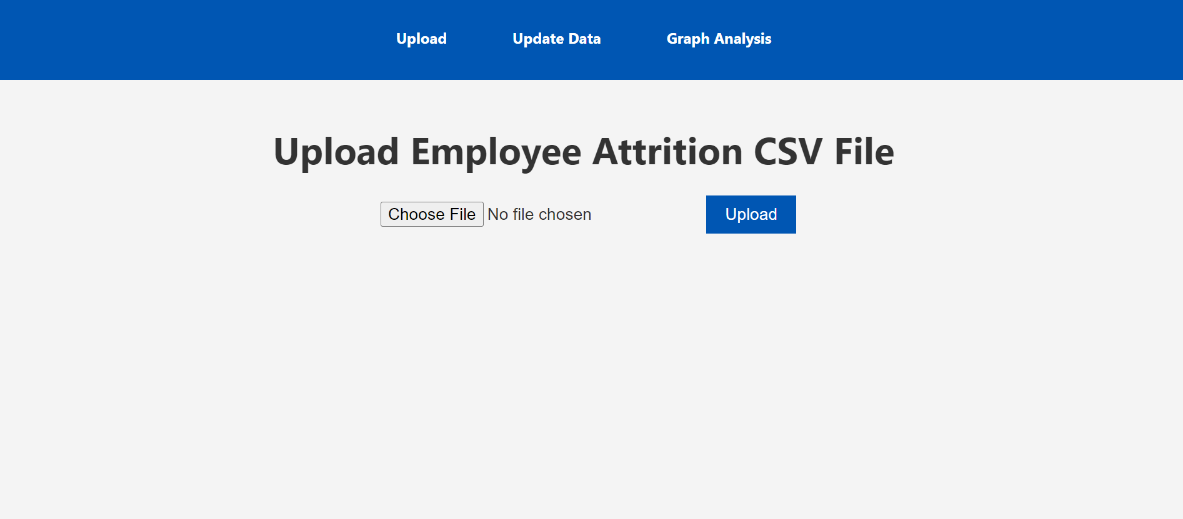

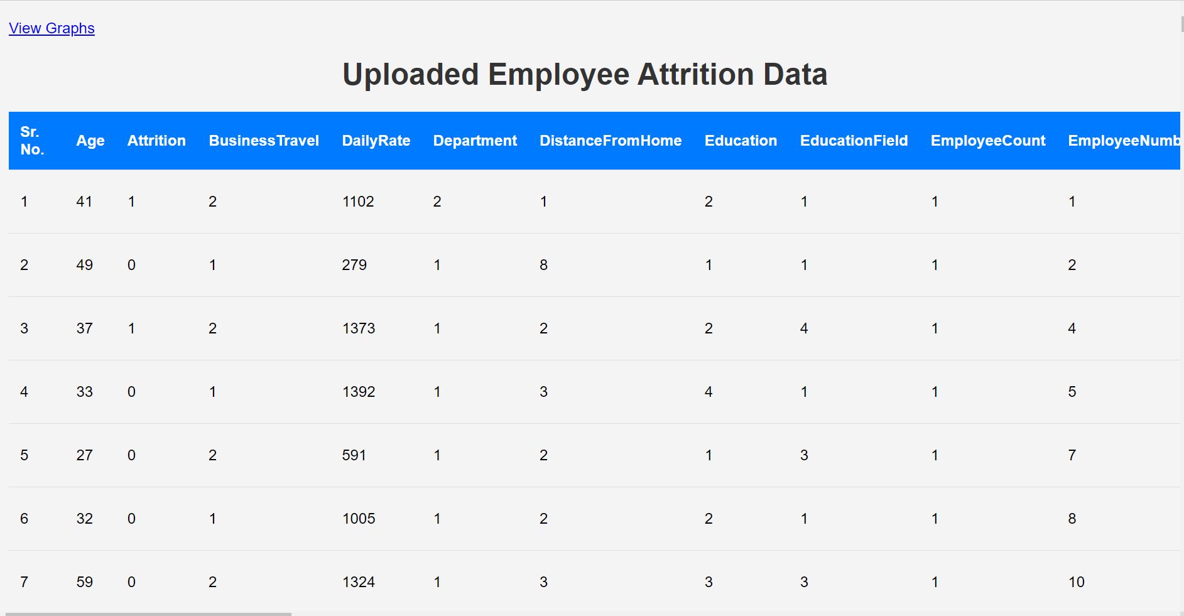

Screenshots

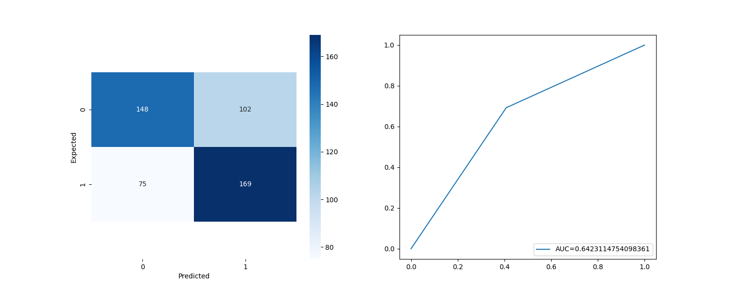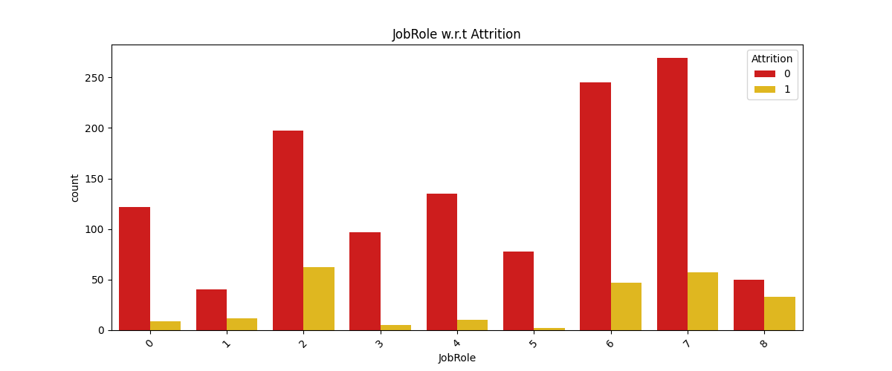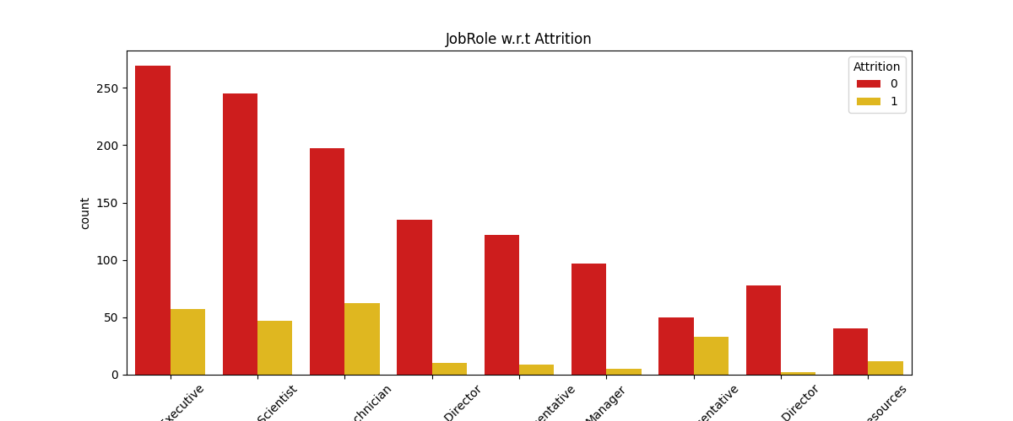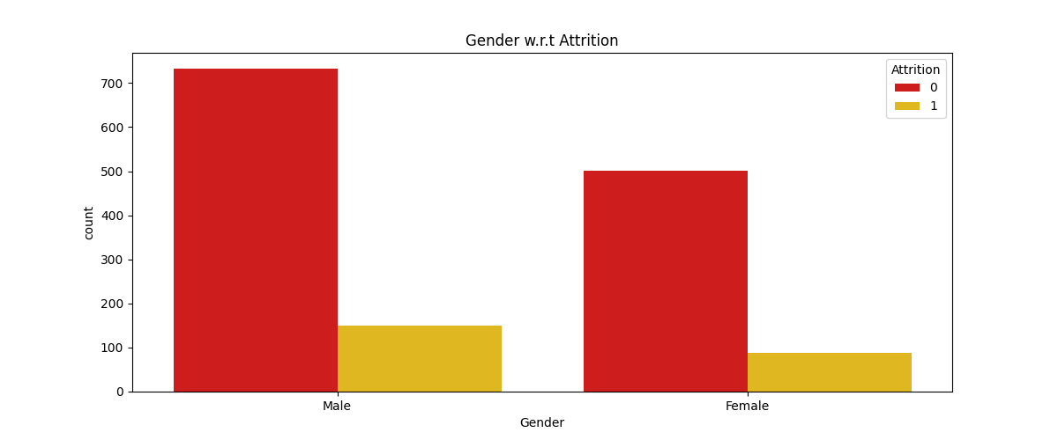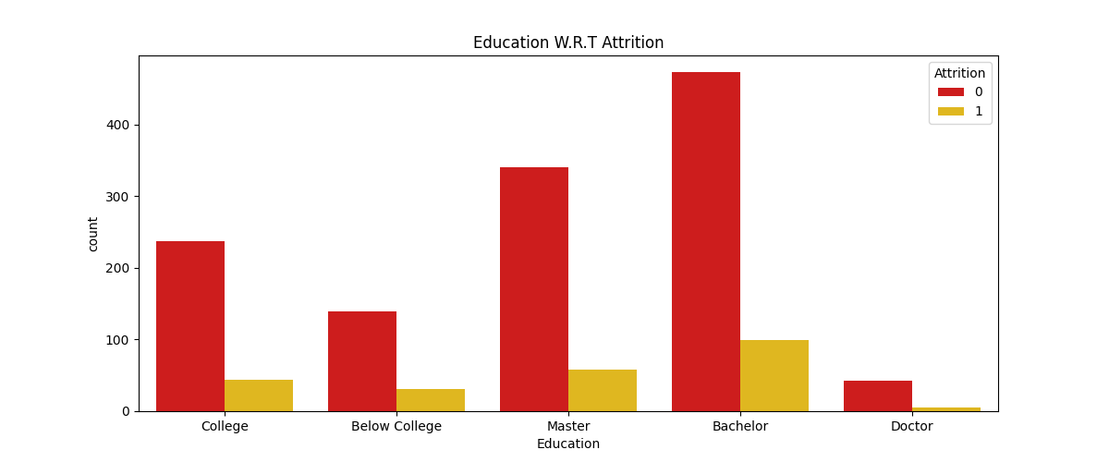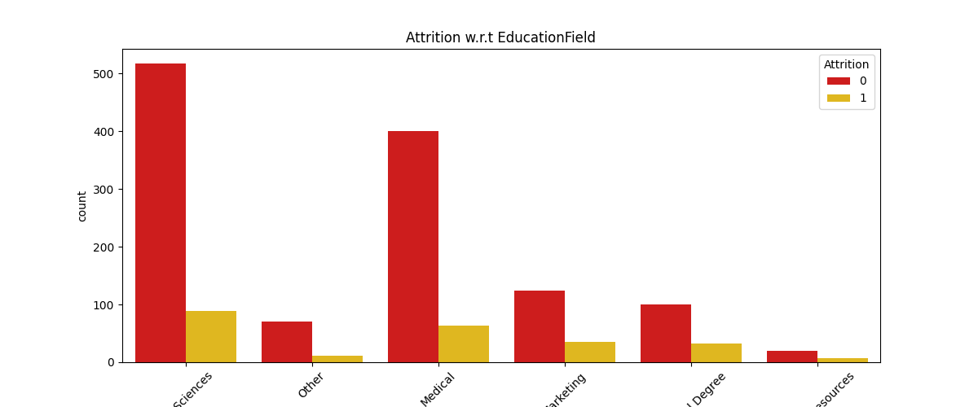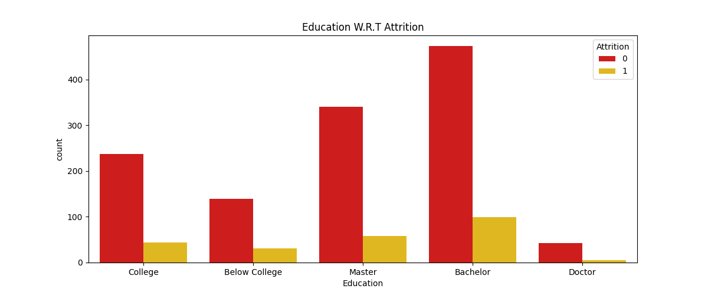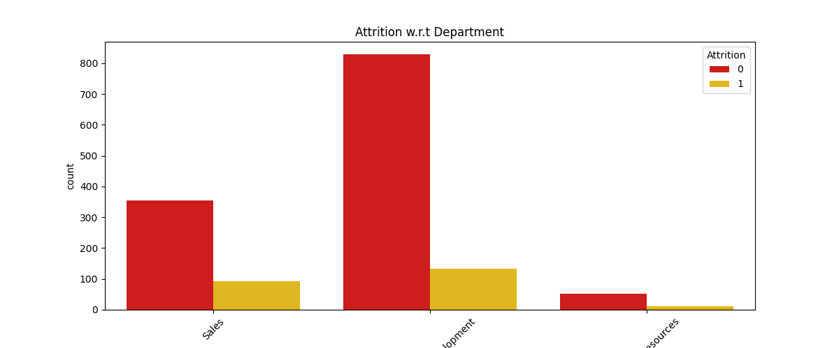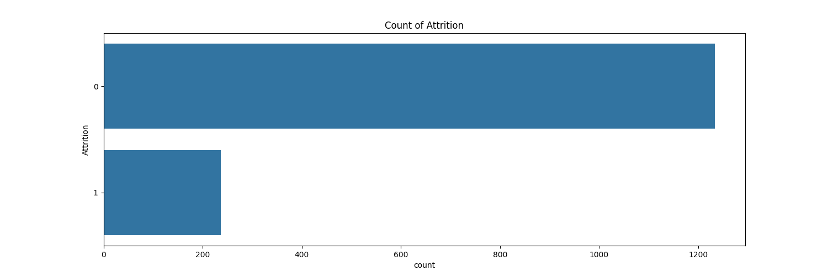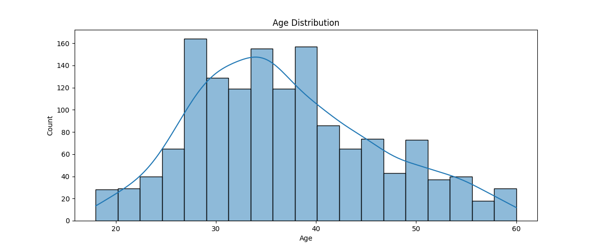



**7. CONCLUSION**

**8. REFERENCES**

**8. REFERENCES**

**8. REFERENCES**

**8. REFERENCES**